**PROJECT REPORT**

**Thrift Fashion**

**Contents**

* **Definition of the problem**
* **Requirement analysis**
* **Design phase**
* **Architecture of web application**
* **Evaluation/Testing**
* **Project tracking and monitoring activities**
* **Documentation section**
* **Source code**
* **User guide**

1. **Definition of the Problem:**

People often discard clothing items when they are no longer in use. They buy clothing from mails, online retail stores, or regular neighborhood stores and later, when these clothes outgrow their utility, they throw them away or dump them in bins. This has even happened in the case of high cost clothing. People who can afford expensive fashion typically do not like to repeat their outfits. They move on to buy newer items barely after using current items on two or three occasions. The older ones are then just discarded. This causes burden on the planet because as the number of such discarded fashion (which is still in good condition, nevertheless) increases, the effort to dispose them also increases.

These days, recycling, sustainability, and reuse are not just buzzwords, but actionable behaviors to support a better planet. Instead of discarding clothes that are still in good condition, but no longer required by the original buyers, these clothes can be sold as thrift fashion or pre-used clothing.

1. **Requirement Analysis:**

* **List of inputs to the system**
* User login
* Order placed
* Feedback
* **List of output from to the system**
* Feedback show (admin panel)
* Order placed show (user & admin both)
* **Hardware and software required for implementing the project**

The software used in the php core and mysql.

1. **Design Phase:**

* **Designing the GUI Standards**

Thrift fashion create multiple pages and links our pages for other pages each pages look simple and respect to appearance and theme. Each pages style, color of the labels, design the responsive header and footer and the all form/pages.

* **Designing The Database**
  + - * + **Admin**

This is admin login table

* + - * + **Cart**

This is user add cart table

* + - * + **Messages**

This is user feedback table

* + - * + **Orders**

This is user placed orders table

* + - * + **Products**

This is products table but only admin add products

* + - * + **Users**

This is User login table

* + - * + **Wish list**

This is add your favorite products add table

**Designing the process modules**

* User Login
* User Register
* Order products
* Search

**Designing the coding standards**

* Safe to use:

The system should not result in many malicious downloads or unnecessary file downloads.

* Accessible:

The system should have clear and legible font’s user-interface elements and navigation elements.

* Security:

The system should implement adequate security measures such as authentication For example: only registered user can access certain feature.

1. **Architecture of web application:**

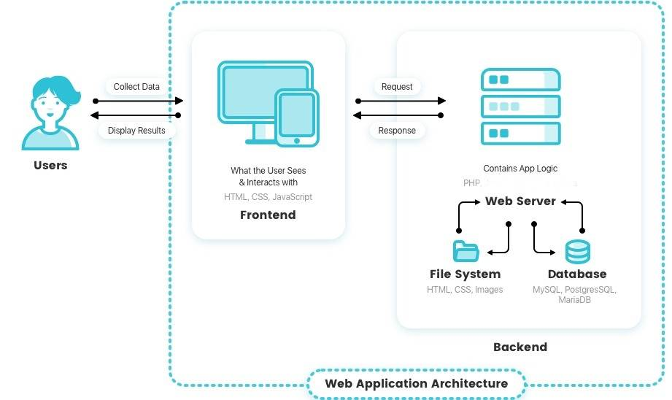

**Data Flow Diagram (DFD)**

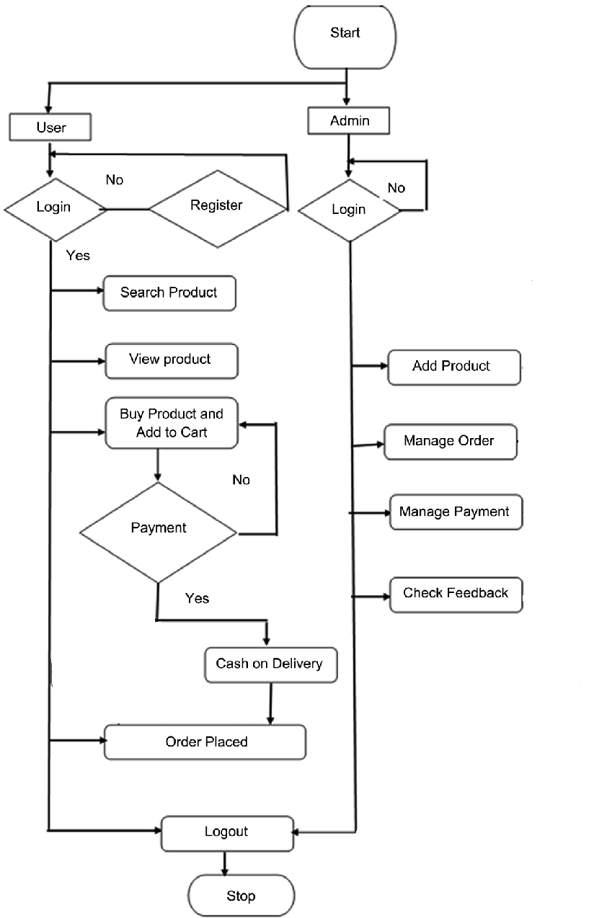

**Entity Relationship Diagram (ERD)**

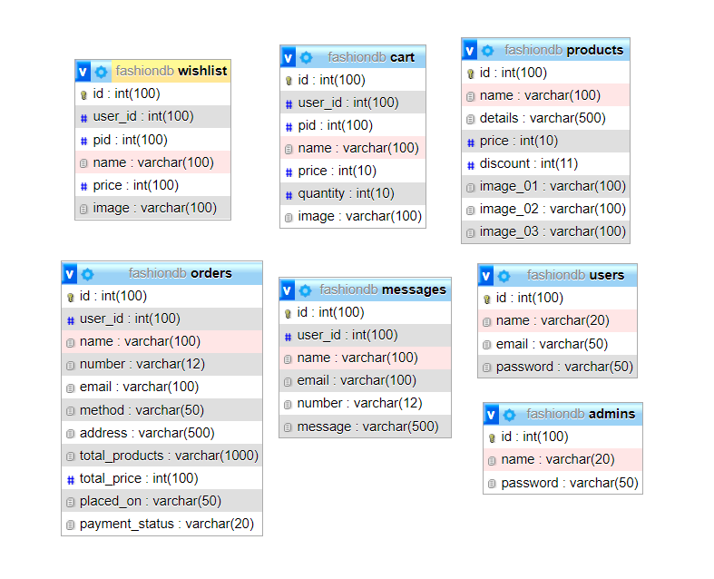

**Database Design:**

The database design structure of different tables is given in the following sections:

|  |
| --- |
| Table: admins |

|  |  |  |  |
| --- | --- | --- | --- |
| Field name | Data type | Key | Description |
| Id | integer | PK | Storing id of the admin (auto generated identifier of this table) |
| Name | varchar |  | Stores the username of admin |
| Password | varchar |  | Stores the password of admin |

|  |
| --- |
| Table: cart |

|  |  |  |  |
| --- | --- | --- | --- |
| Field name | Data type | Key | Description |
| ID | Integer | PK | Stores the cart ID of the user |
| User ID | Integer |  | Stores the Customer ID of the user |
| P ID | Integer |  | Stores the product ID of the product |
| Name | Varchar |  | Stores the product name in cart |
| Price | Integer |  | Stores the Product price in cart |
| Quantity | Integer |  | Stores the quantity of products |
| Images | Varchar |  | Stores the images of products |

|  |
| --- |
| Table: messages |

|  |  |  |  |
| --- | --- | --- | --- |
| Field name | Data type | Key | Description |
| Id | Integer | PK | Stores the Id of Message |
| User Id | Integer |  | Stores the customer Id |
| Name | Varchar |  | Stores the name of user |
| Email | Varchar |  | Stores the Email of user |
| Number | Varchar |  | Stores the Number of user |
| Message | Varchar |  | Stores the Message of user |

|  |
| --- |
| Table: Orders |

|  |  |  |  |
| --- | --- | --- | --- |
| Field name | Data type | Key | Description |
| Id | Integer | PK | Stores the Id of Order |
| User ID | Integer |  | Stores the Id of user |
| Name | Varchar |  | Stores the name of user |
| Number | Varchar |  | Stores the number of user |
| Email | Varchar |  | Stores the email of user |
| Method | Varchar |  | Stores the method of payment of order |
| Address | Varchar |  | Stores the address of user |
| Total Products | Varchar |  | Stores the Quantity of product |
| Total Price | Integer |  | Stores the total price of order |
| Placed on | Varchar |  | Stores the Date on which order is placed |
| Payment Status | Varchar |  | Stores the payment method |

|  |
| --- |
| Table: Products |

|  |  |  |  |
| --- | --- | --- | --- |
| Field name | Data type | Key | Description |
| Id | Integer | PK | Stores the Id of Product |
| Name | Varchar |  | Stores the name of product |
| Detail | Varchar |  | Stores the Detail of product |
| Price | Integer |  | Stores the Price of product |
| Discount | Integer |  | Stores the Discount price of product |
| Image1 | Varchar |  | Stores the Front photo of product |
| Image2 | Varchar |  | Stores the Detail image of Product |
| Image3 | Varchar |  | Stores another Detail image of product |

|  |
| --- |
| Table: Users |

|  |  |  |  |
| --- | --- | --- | --- |
| Field name | Data type | Key | Description |
| Id | Integer | PK | Stores the Id of User |
| Name | Varchar |  | Stores the Name of User |
| Email | Varchar |  | Stores the email of user |
| Password | Varchar |  | Stores the password of user |

|  |
| --- |
| Table: Wish list |

|  |  |  |  |
| --- | --- | --- | --- |
| Field name | Data type | Key | Description |
| Id | Integer | PK | Stores the Id of wish list |
| User Id | Integer |  | Stores the Id of User |
| P ID | Integer |  | Stores the Id of Product |
| Name | Varchar |  | Stores the name of Product |
| Price | Integer |  | Stores the Price of product |
| Image | Varchar |  | Stores the image of Product |

1. **Source Code:**

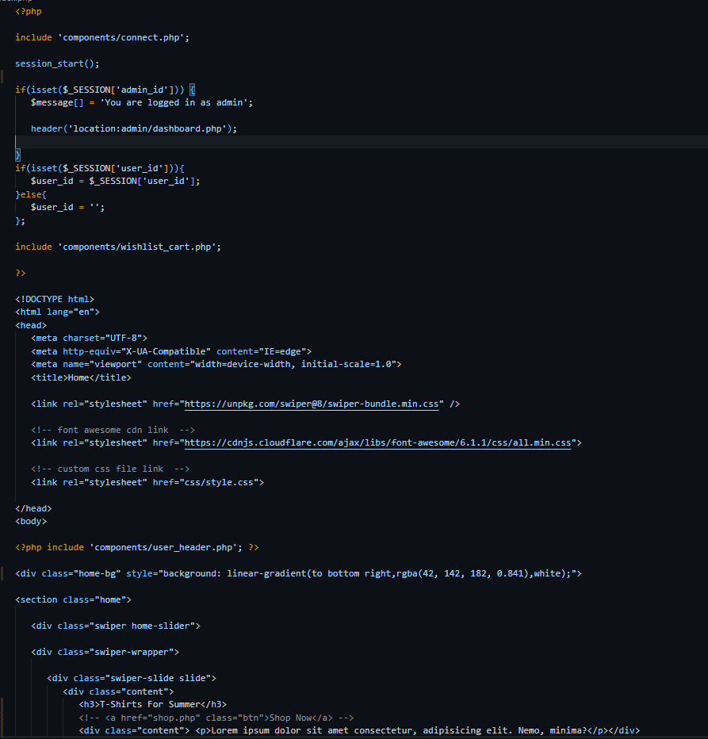

1. **User Guide:**
2. **System requirement**

|  |  |  |
| --- | --- | --- |
| s.no | Items | description |
| 1. | Operating system | Microsoft windows 8.1, 8, 10 or higher |
| 2. | Database | Mysql |
| 3. | Software | Visual studio code 2017 or higher (with php core templates) |
|  |  |  |

1. **Install and run application**

Step 1: wampserver.

Step 2: import sql file.

Step 3: copy folder in www.

Step 4: run ‘localhost:2124/thriftfashion’